|  |  |
| --- | --- |
| **Name:- Aryan Dilipbhai Langhanoja** | **Roll Number:- 92200133030** |
| **Subject Name and Code:-** Foundation Skills On Sensor Interfacing (01CT1103) | **Date of Experiment:- 17-11-2022** |

|  |  |
| --- | --- |
| Task:- |  |

Interface temperature and humidity sensor with arduino and show the results on serial monitor.

|  |  |
| --- | --- |
| Components: |  |

* Arduino Uno R3
* DHT-11 humidity and Temperature Sensor
* Jumper Wires (Male To Male)
* Bread Board
* Laptop Or PC

|  |  |
| --- | --- |
| About the Project:- |  |

* In thisproject, we are going to interface Temperature and humidity sensor with Arduino.This Sensor is helpful to measure the temperature of surroundings.
* The DHT-11 Digital Temperature And Humidity Sensor is **a basic, ultra low-cost digital temperature and humidity sensor**. It uses a capacitive humidity sensor and a thermistor to measure the surrounding air and spits out a digital signal on the data pin (no analog input pins needed).

|  |  |
| --- | --- |
| Output (you circuit implementation):- |  |

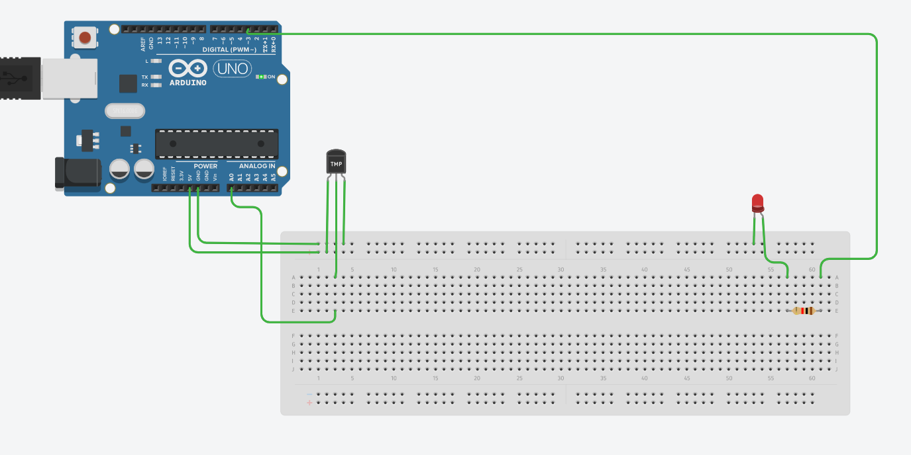

|  |  |  |
| --- | --- | --- |
| Schematic:- |  |  |

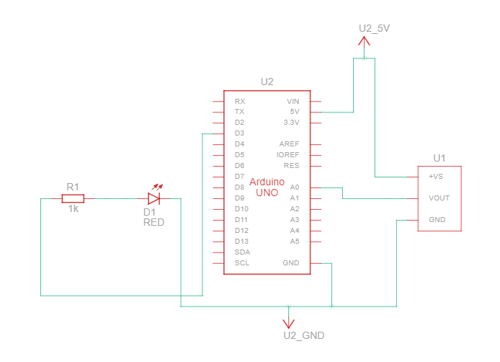

|  |  |
| --- | --- |
| Application:- |  |

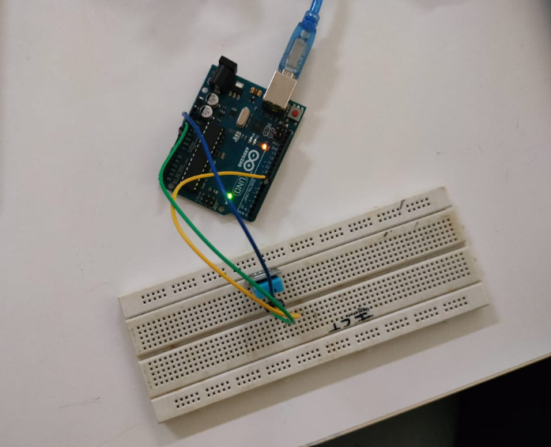

|  |  |
| --- | --- |
| Code :- |  |

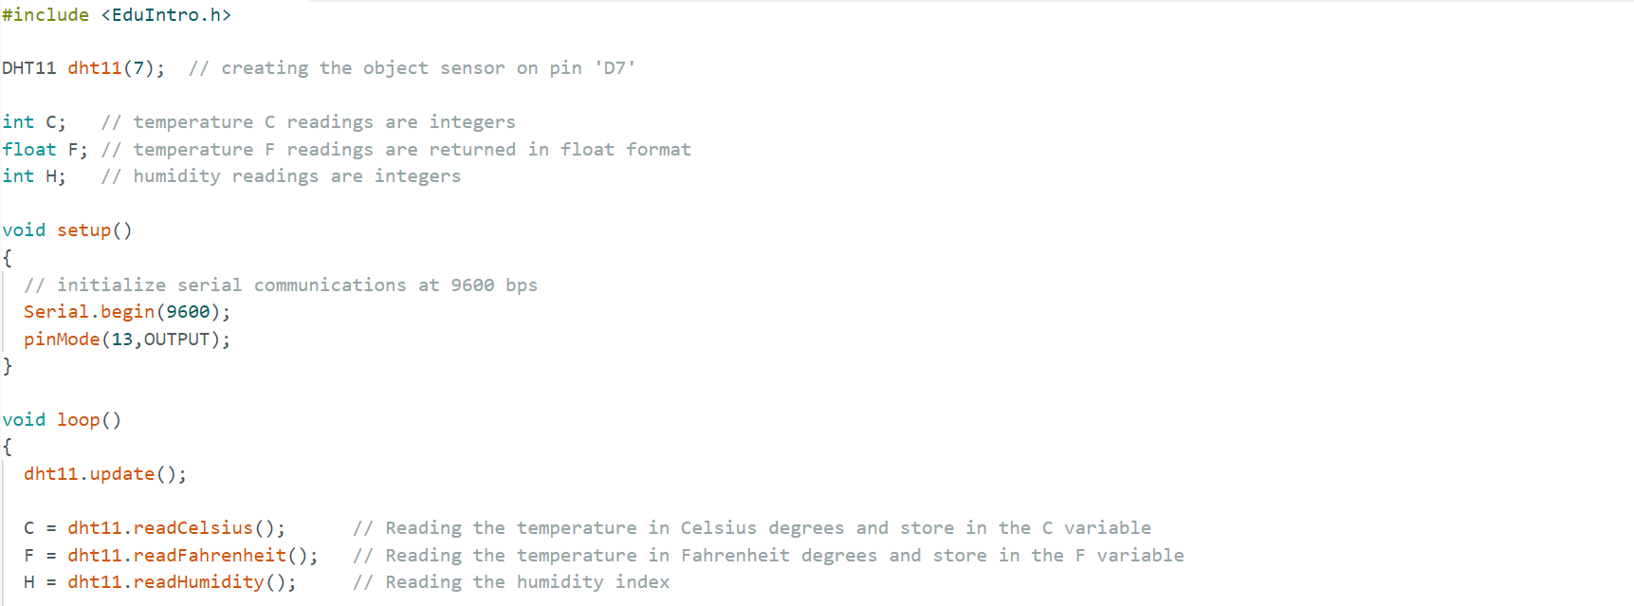

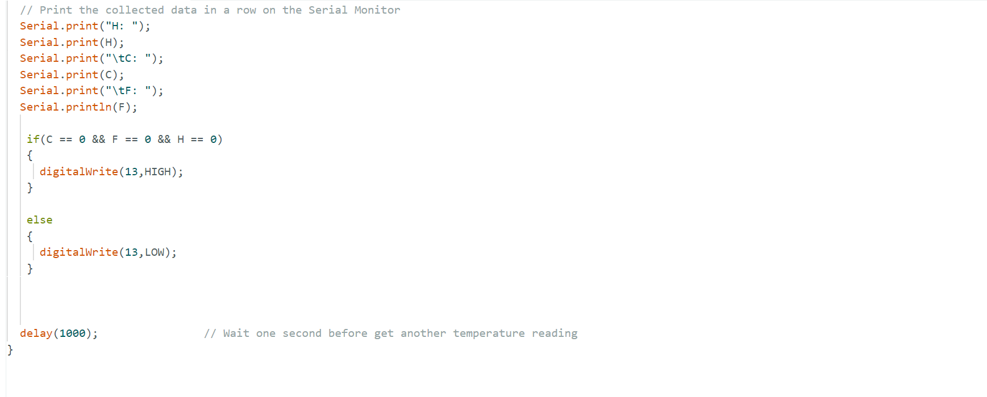

|  |  |
| --- | --- |
| Results Of Serial Monitor :- |  |

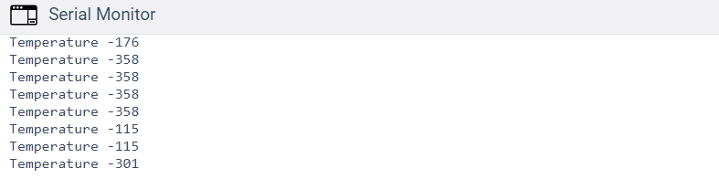

|  |  |
| --- | --- |
| Conclusion:- |  |

* In This Experiment, We Learnt That How To Interface Temperature and humidity sensor DHT-11 With Arduino.